MACH4METAL

Metalworking machinery
Transito 21,
6909 DA BABBERICH
Netherlands
Tel. +31 (0)316 – 247123
Fax. +31 (0)316 - 247956
info@mach4metal.com
www.mach4metal.com

Account No: 66.52.13.883
IBAN : NL33 INGB 0665 2138 83
BIC : INGBNL2A

Portal milling KAO MING KMC 2000

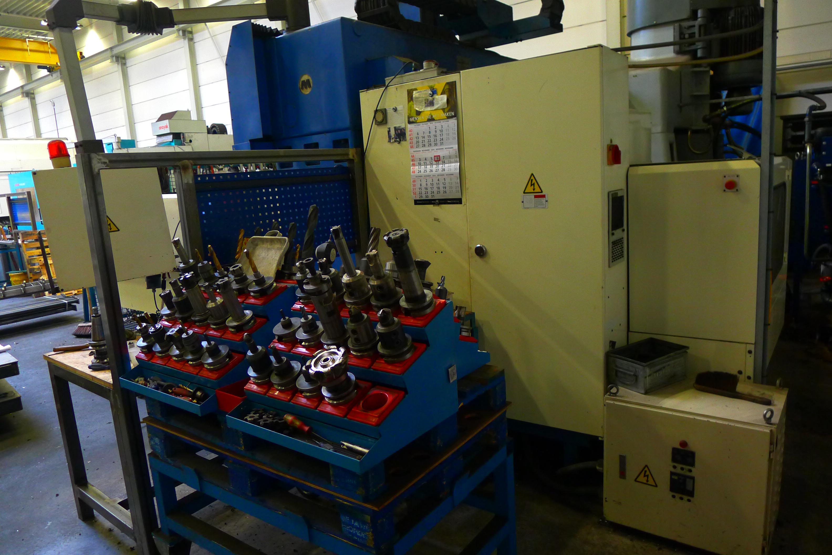
- Make : KAO MING Taiwan
- Typ : KMC – 2000 SD
- No : 25060
- Age : 1995 . 11

- Table size:
- Length : 2.000
- Width : 1.250
- Load : 4.000
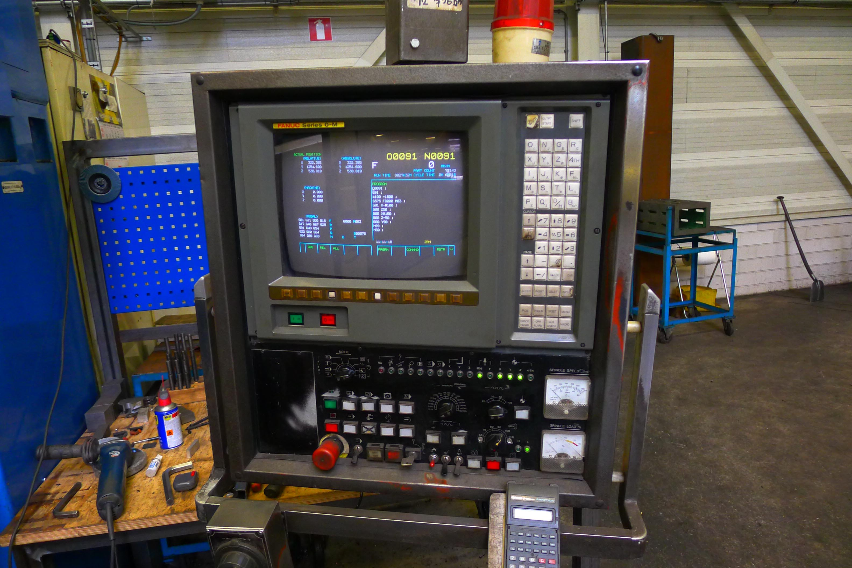
- Travel – Stroke:
- X : 2.030
- Y : 1.400
- Z : 700

- Spindle : Iso 50
- Spindle speed : 20 – 3.200
- Motor power : 20 Hp

- Rapid 12.000 mm/Min
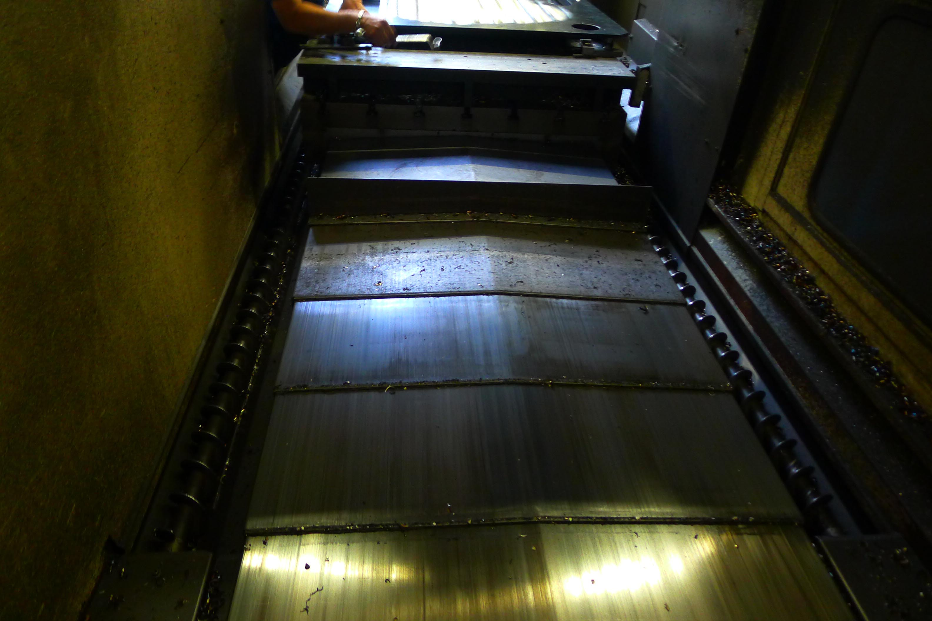
- ATC 30 position Chain tool changer
- CNC Fanuc O-M

- Dimensions
- Length : 5.600
- Width : 4.139
- Height : 3.750
- Weight : 18.000

Please Note: The above information has been obtained to the best of our ability and belief from, and from the manufacturers where possible. It is given in good faith, but its accuracy can not be guaranteed. Accordingly, it will not form a representation or constitute contractual terms. We advise you to check any vital details!

